**LAB TASK#3**

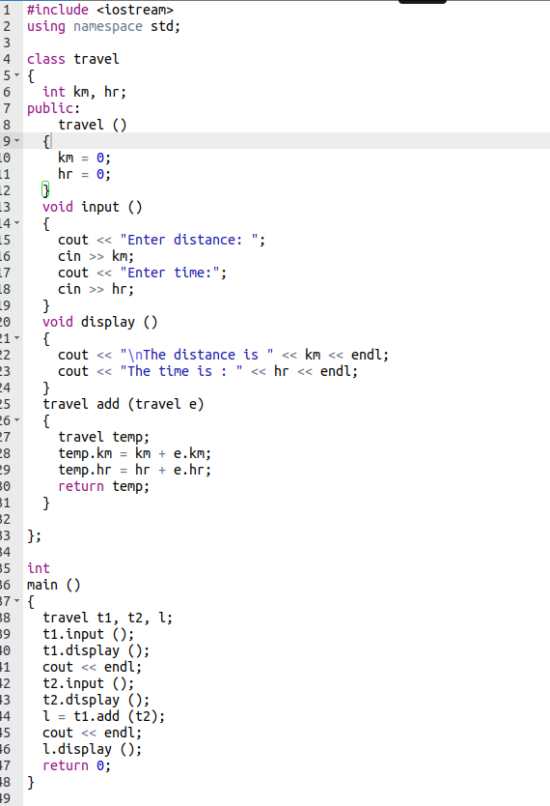

**OUTPUT**

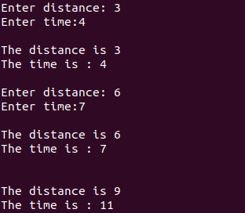

**LAB TASK # 4**

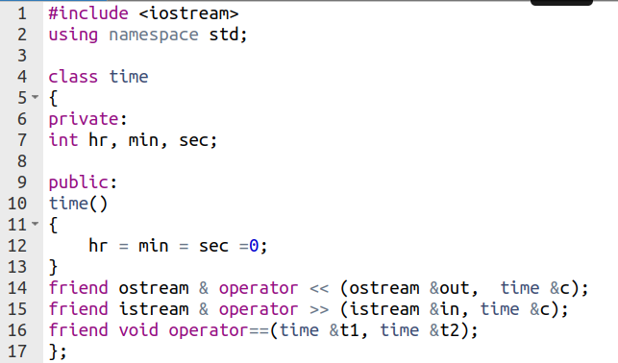

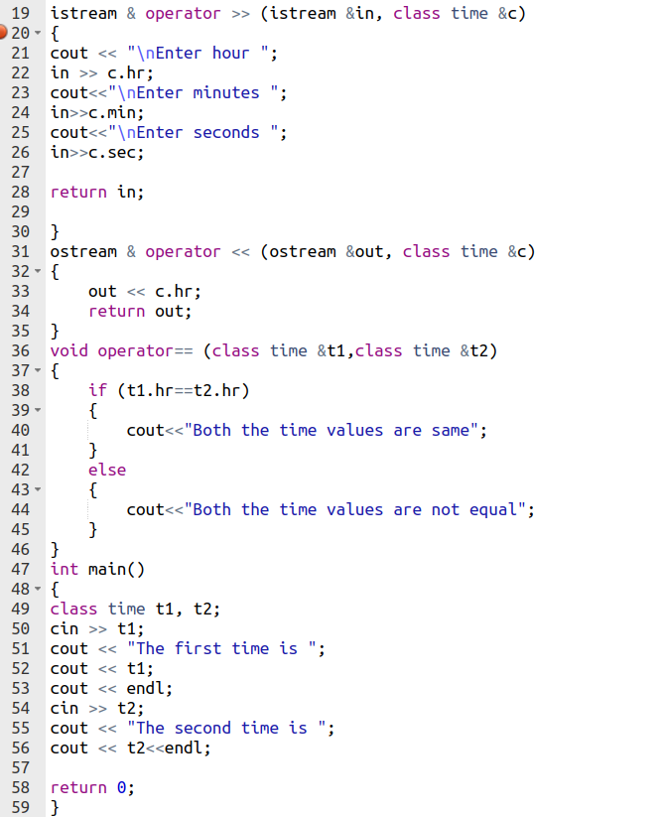

**OUTPUT**

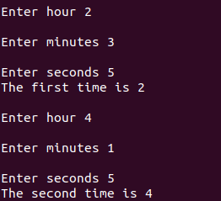

**Conclusion:**

In this lab I revised all the previous concepts that include Structs, Classes, Friend Functions, Operator overloading and all about private and public variables and functions.